

University of Petroleum &

Energy Studies

# SCHOOL OF COMPUTER SCIENCE

**Name**: Nancy **Course**: BTech CSE **SAP ID**: 500121761 **BATCH**: 2

***PRESENTED TO: Dr. Syed Sajid Hussain***

***PROJECT - LIBRARY MANAGEMENT***

1. **Creating the Database**

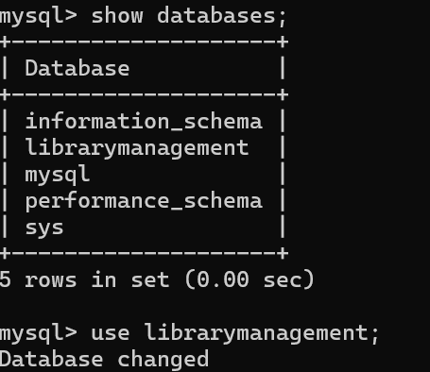

**2. Create Tables**

**a) Create the Books Table**

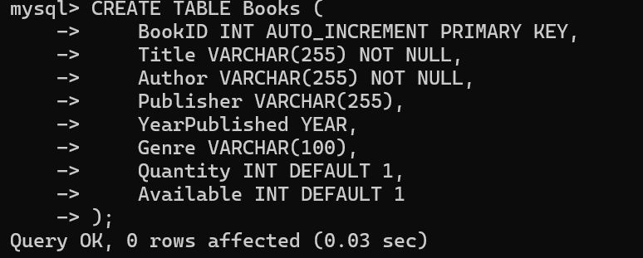

**b) Create the Members Table**

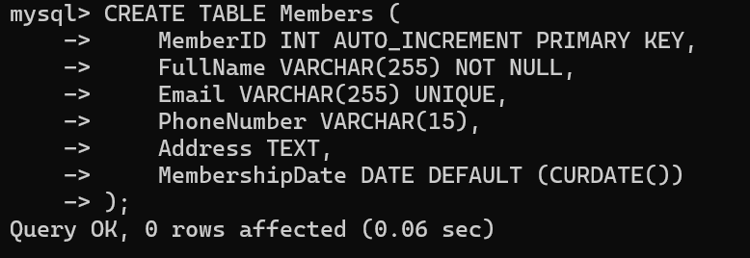

**c) Create the Transactions Table**

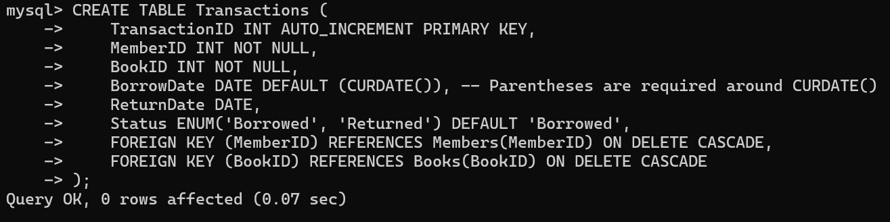

**Tables**

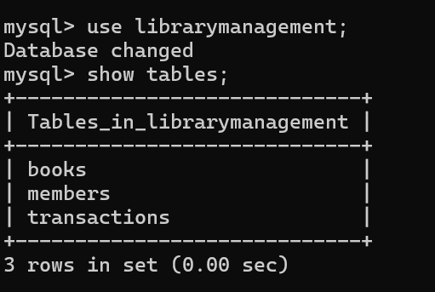

**3. Insert Sample Data**

**a) Insert Books Data**

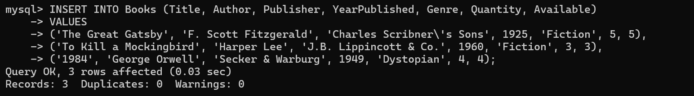

**b) Insert Members Data**

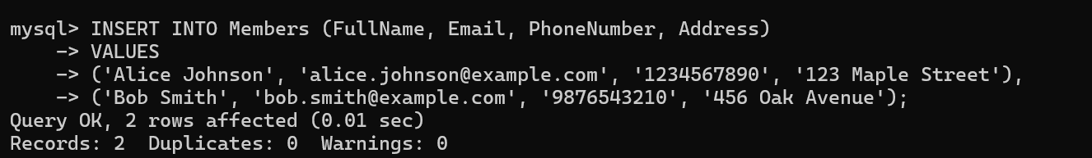

**4. Create Stored Procedures**

**a) Borrow a Book**

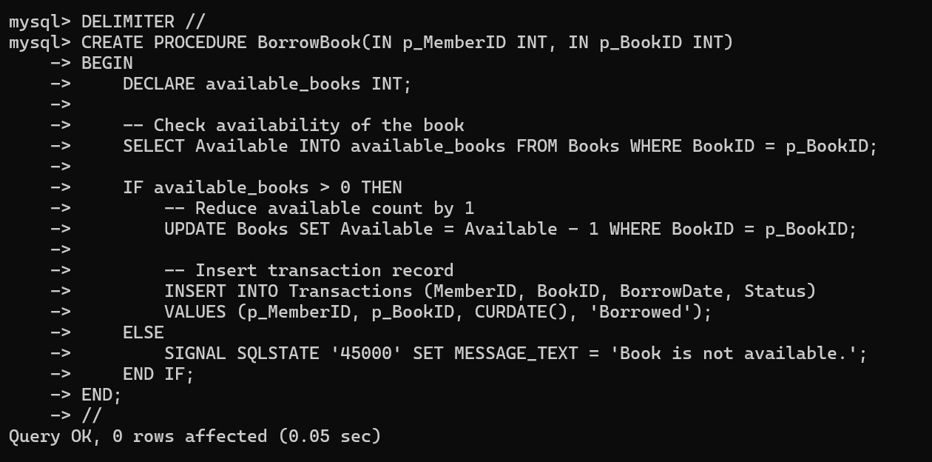

**b) Return a Book**

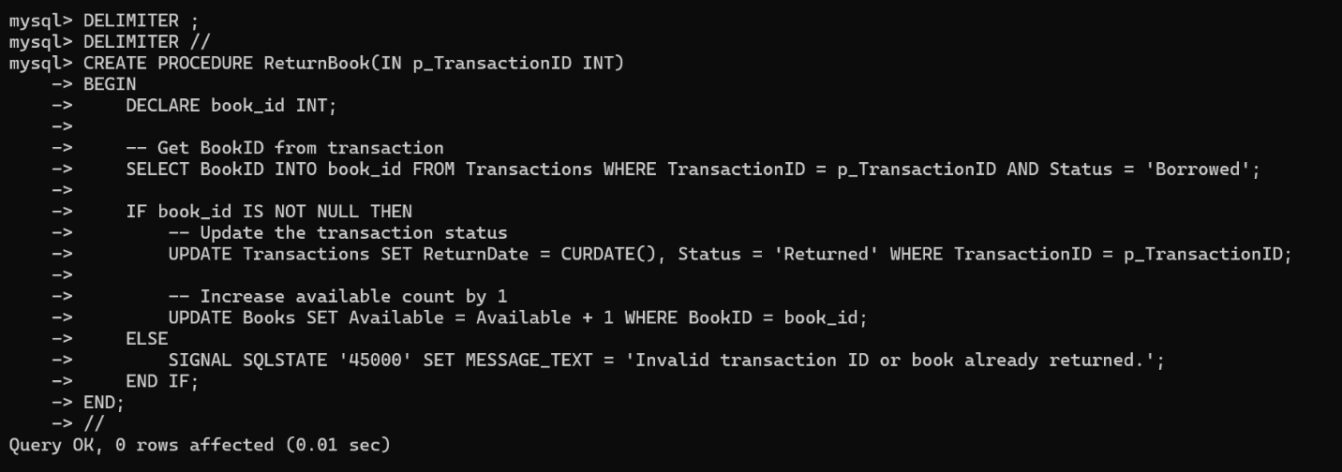

**5. Example Operations**

**a) Borrow a Book**



**b) Return a Book**

